Odawa Night Owl 2019
27 - 28 April 2019
This event is open to Scouting and Guiding Groups
across Ontario and Quebec.

Please share this information amongst your neighbouring Scouting/Guiding Groups, including any registered members (Rovers,Venturers, Rangers, senior Scouts, senior Pathfinders, other Guiders/Scouters) that may be interested in volunteering in supporting this event.

The Odawa Night Owl challenge will be held overnight 27 - 28 April 2019 at the Apple Hill Scout Reserve (18739 Concession 2 Road Apple Hill, ON K0C 1B0 - South side of Apple Hill Scout Reserve (AHSR) ). It is open to Pathfinder and Scout age Youth (senior Cubs and Guides may participate at the discretion of their Groups).

The actual overnight hike, where the Youth go, as teams of 4-6 Youth (Pathfinders and Scout age youth – senior Guides and senior Cubs may participate as part of linking if their parent Guiding/Scout Group allows), from station to station to undergo various fun challenges for points - it starts shortly after the Opening ceremony in front of the main Cabin at 7 PM Saturday night and ends at 1 AM Sunday morning with the closing and trophy ceremony at about 7:30 AM Sunday morning, with pickup and departure for home after 8:00 AM. All participants and volunteers are to have departed Apple Hill Scout Reserve by no later than Sunday 10:30 AM.

Night Owl Stations are manned and operated by Senior Youth (Rovers,Venturers, Rangers, senior Scouts, senior Pathfinders) and/or Adult Scouters/Guiders. As well, such staff will be conducting safety patrols along the various routes that the Youth participants will be using. Wherever Adults are involved (whether manning/operating stations, conducting roving safety patrol or (in the case of some Pathfinder/Guides units or Scouters accompanying patrols made entirely of senior cubs) accompanying one’s youth), there are to be a minimum of two adults present at all times as per Scouts Canada Policy for Youth Safety.

Teams may return to the main bivouac area at South side of Apple Hill Scout Reserve anytime they wish throughout the night as long as they check at the Registration at the main cabin upon completion of their trek. The team with the most points gets their name on the Night Owl Trophy and bragging rights for the year.

Groups are to arrive onsite at Apple Hill Scout Reserve AFTER Three PM (3:00 PM/15:00 hrs) 27 April (Saturday) to commence setup of their camp site so as to not interfere with the ongoing work for AHSR Work Day – participants/volunteers may also chose to visit and setup their stations that they may have volunteered to run or just walk about the route for Night Owl in daylight with their Youth. Registration of teams will take place between 4 PM and 6:30 PM at the main cabin.

Participants are to bring the necessary gear to stay the night, as well as personal survival kits and personal first aid kits – each group are to ensure they have a qualified first aider as well as a group first aid kit onsite. Each group is responsible for any necessary feeding arrangements for their Youth including provision of snacks and drinks as required. Potable water will need to be brought by each group as there is no source of potable water at Apple Hill Scout Reserve. As well, groups should not forget to bring toilet paper (particularly while out about away from main camp). All trash and recycling are to be brought home from camp by each Group attending as Apple Hill Scout Reserve will not have arrangements in place the weekend of Night Owl to handle and dispose of such material (Carry In/Carry Out).

Note: To prevent pest infestations, no outside firewood is to be brought to camp – any firewood required will be available onsite.

The cost for this activity is $15.00 per youth participant which covers the cost of the badge and camp usage fees and other minor expenses (groups will naturally tack on their addition charges for their own Youth to attend to cover expenses such as feeding etc) – there will to be a $7.00 charge for Adult volunteers and Youth volunteers running stations/roving patrols to ensure this activity remains financially viable. Cheques for event payment are to be made out to “Scouts Canada – Odawa Area”

There is no pre-registration deadline to participate in this activity – registration will be done onsite Saturday 27 April.

If required, more details may be sent out via separate email the week of 16 April 2019 to Odawa Area Scout Groups, other Scout Groups in Voyageur Council/Quebec Council and any Girl Guide Groups that may be interested in attending as participants or volunteers to run stations or act as roving safety patrols.

Please indicate your interest in potentially participating, volunteering to run a Station or assist in another aspect of Night Owl including roving safety patrol by emailing Scouter Stephen Bellefleur at Odawanightowl@odawa-scouting.ca, including “Odawa Night Owl 2019 – Group Name – Volunteering” in the email header/subject line indicating potential level of participation as follows, so that Scouter Stephen Bellefleur may forward any pertinent information directly to you and/or your group regarding participation and/or volunteering in support of this great adventure for your members.
If at all possible, please email to Scouter Stephen at Odawanightowl@odawa-scouting.ca , using the subject line “Night Owl 2019 Participant Estimate – Group Name” in the email the following information:
- Name of their Group,
- Name and email address of the Group’s lead for Night Owl (so any new information needs to be sent out it is routed to the right contact),
- The likely/approximate number of participants,
- The likely number of volunteers (Adults/senior Youth (Venturers, Rangers, senior Scouts/senior Pathfinders))
- If there is any past activity/station that you may wish to run this year.

Note: No pets except service animals allowed on the Camp premises as per Scouts Canada policy (pets accompanying adults dropping off Youth must stay must stay in vehicles).

Apple Hill Scout Reserve (18739 Concession 2 Road Apple Hill, ON K0C 1B0 - South side of Apple Hill Scout Reserve (AHSR)
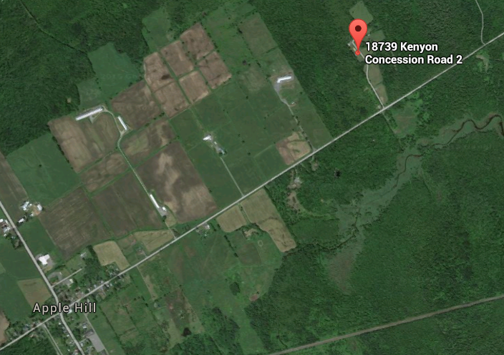
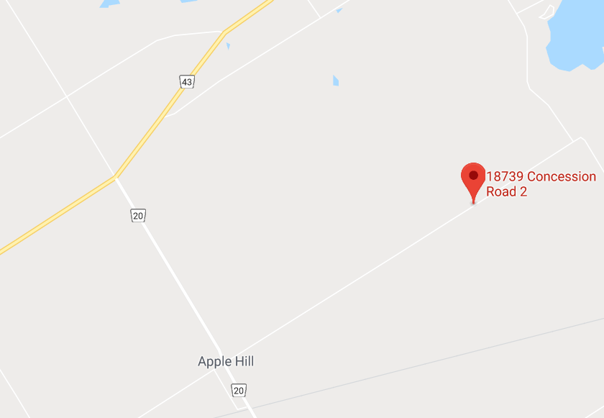
Apple Hill Scout Reserve
(18739 Concession 2 Road Apple Hill, ON - South side of Apple Hill Scout Reserve (AHSR))

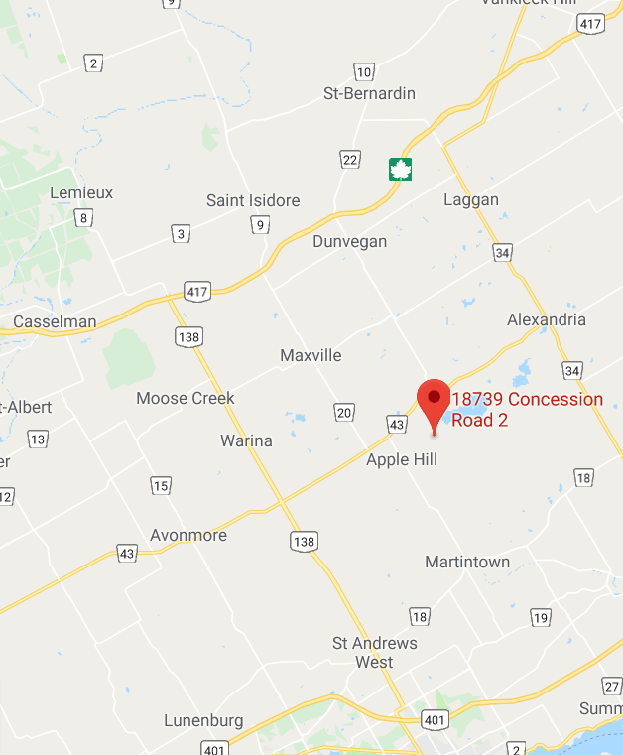

Odawa Area
Night Owl Challenge
2019

Detailed Event Instructions

The night Owl challenge will be held at the Apple Hill Scout Reserve 27 - 28 April 2019 (Saturday noon to Sunday morning) at Apple Hill Scout Reserve using the South Side of the Camp as base camp.

Groups may arrive any time after 1500 hrs Saturday April 27th (Groups wishing to arrive Friday night and make a weekend of it are to contact AHSR Ranger Staff directly to undertake such arrangements). Camp closing ceremonies will be at 0730 hrs (7:30 AM) Sunday morning with pick-up anytime afterwards (ie about 8:00 AM or so) at the South Side of Camp.

The youth and adults should bring the necessary gear and tents to stay the night, as well as their personal survival and first aid kits as they see fit (equipment list excluding camping equipment is provided below).

Provision of potable water, meals, snacks, hot chocolate, coffee and Sunday breakfast is a group responsibility.

Please fill out the REGISTRATION FORM attached below and submit as a paper copy on Saturday 27 April with payment at the Registration site at the main cabin.

Note: there is no registration cut-off for participation in this event – we will accept all participants/volunteers up to and including the start of Night Owl on 27 April, even if there was no heads up in advance of probable numbers attending.

The cost for this activity is:
$15.00 per youth doing the hike,
$7 for everyone else (ie Scouters/Guiders and Youth volunteers assisting in running stations and/or roving safety patrols etc).

Please note: Payment collected for this event is used to cover the cost of the Camp Fee, materials and badges). The fee for this activity will be collected the day of the event. Please make all cheques out to Scouts Canada – Odawa Area, with Night Owl 2019 in the memo.
Additional Night Owl Challenge Information

Night Owl Challenge is an exciting all night event, open to Scouting and Guiding members, that focuses on developing teamwork while having a good time and enjoying the outdoors. This year, the event will again be coordinated by Scouter Stephen and his band of merry volunteers with assistance from other Scouters and Guiders and Venturers/Rovers/ Rangers/senior Scouts/Pathfinders running various stations and or conducting roving safety patrols.

Throughout the night, Patrols of 4-7 youth will compete in a series of interesting challenges and activities scattered throughout the northern part of the Camp in order to score points (sketch maps with points will be provided to all on the day of the event). Whichever Patrol has the most points by the end of the night is the winner – if there is a tie for First Place, an additional challenge will be undertaken in the morning to break the tie. Youth from Groups with insufficient numbers to form a Patrol onto themselves may join up with existing formed Patrols or form a composite Patrol the day of the event.

Groups should arrive at Apple Hill Scout Reserve between 3 PM (1500 hrs) and 5 PM (1700 hrs) to setup their camping area and prepare their teams – groups are to ensure they have Adult supervision (ie Scouters/Guiders) onsite to look after their Youth arriving onsite. Information on where groups may set up their tents will be available at the registration at the main cabin.

- Check in/registrations of Groups and Patrols will run from 1600 hrs (4:00 PM) to 1845 hrs (6:45 PM) at the main cabin. All Groups must register prior to their Patrols registering. Personnel running stations need to check into registration prior to confirm their assigned stations and receive any material/directions to run their station prior to departing to setup their stations. Opening ceremony will be in the northern part of the Camp in front of the main cabin at 1900 hrs (7:00 PM) for all less those volunteers running stations (as they will have departed to their station locations).

- Stations will be open at 19h30 (7:30 PM) and events will run through the night until completion at about 0100 hrs (1 AM) – Youth are to be at their designated start station no earlier than 1930 hrs (7:30 PM) to allow Rovers/Venturers/Rangers/Senior Scouts/Pathfinders and Guiders/Scouters time to setup their stations.

- Departure will be early Sunday morning after the winners are announced at the Closing Ceremony at 0730 hrs (7:30 AM) – thus departure will likely sometime after 8:30 AM depending on Groups packing up and cleaning their camp sites – please check out with staff at the main cabin .

SUGGESTED EQUIPMENT LIST TO DO THE OVERNIGHT HIKING ACTIVITY
(separate from any equipment required to sleep overnight in the bivouac area in the South side of the Camp.)

PER MEMBER (in their backpack on person/worn)
- Mug, spoon
- Change of clothes including spare dry socks
- Appropriate warm outdoor attire including water resistant foot wear – youth and adults should be prepared for snow (and potentially frozen ice) along the trails
- Rain Gear (include small garbage bags/bread bags to wear as footwear inserts if footwear gets wet)
- Spare socks
- Tuque, gloves/mitts
- Flashlight/head lamps and spare batteries (headlamps preferable) with spare batteries
- Folding pocket knife/multi tool if so allowed by their Scouter/Guider – no fixed blade knives
- Whistle
- Water bottle with water
- Snacks (nut free)
- Personal first aid/survival kit /fire starter kit (if possible)
- Bug repellent/mosquito netting as they see fit
- Scout Staff/hiking staff if available
- Personal Cell Phone/Smart Phone desirable (will be used for any necessary communications during/at end of the event) – minimum of one per team desirable

PER TEAM
- Two Large Freezer Ziploc bags (one for score sheet, one to protect trail map)
- Compasses (min 1 per team – helps confirm direction to follow along the paths in the forest)
- Small Group First Aid Kit
- GPS (optional)
- Cell phone (handy in case of emergency/tracking of misplaced teams) – highly desirable

There will be approximately 13 to15 challenges, but the number will ultimately depend on the number of registered senior Youth volunteers/Scouters/Guiders willing to run a station and the minimum two adult Scouting rule for Adults will apply throughout the Camp (isolated stations not run by Venturers/Pathfinders/Senior Scouts will require min two Scouters/Guiders onsite while some stations with visibility with each other may have one Adult Scouter/Guider – roving safety/security patrol are to have two registered Scouters/Guiders and/or be composed of senior Youth). As per Scout Canada Policy, any adult Scouters/Guiders/Adults accompanying a Youth Team must have at least two adults (18 years and older) present at all times. Some simple stations can be grouped together if need be if insufficient volunteers available to run.

Like last year, we have decided to not run the challenges in a particular order - this way the youth can roam to whatever station they wish to complete after they start at their assigned station at the start of the night. They may not get to/complete every station, but they should be able to do most of them done. Teams may stop and return anytime to base camp – all teams must report into registration upon return to the main bivouac in the South end of Camp.

There should be a "Patrol Leader" per team appointed prior to arriving at registration. This patrol leader will be required to sign in at the registration point to receive information on where to set up their tents and any last minute details.

There is ample parking in the South side of Apple Hill Scout Reserve.

Night Owl’s success is due to the efforts of the volunteers stepping up to run fun stations and/or providing safety patrols throughout the night.

Groups that would like to run a station(s) using Senior Scouts/Pathfinders, Venturers, Rangers, Rovers Guiders, Scouters from their Group will be given an opportunity to sign up to run a station or act as a roving safety patrol by contacting Scouter Stephen via email at Odawanightowl@odawa-scouting.ca or on arrival onsite Saturday – a copy of the current status of station manning (along with the draft map for location of the activities) can be found at the separate document that includes the activity map.

To run a station, you will be provided with a full explanation of how your station(s) should run along with the required basic material. If you choose to run a station/challenge, and we urge each group to consider doing so, please bring a tarp and some rope (or light kitchen shelter) to make a shelter for yourselves at your station to avoid getting soaked if it is rainy. As well, you may wish to bring on site additional material to ensure your comfort while awaiting the arrival of Youth (ie folding chair, Coleman lantern for light/heat, perhaps a stove if you wish to make hot soup/hot chocolate onsite for your team running the station).

If you have any additional questions, please feel free to contact Scouter Stephen Bellefleur via email (Odawanightowl@odawa-scouting.ca) or by phone at (613) 834-3129.
Physical Fitness Forms for Non Members
(To be handed in when registering Saturday afternoon/night 27 April 2019)
To be completed for all participants (Scouters/Guiders/Youth Participants alike) and handed in at Registration in a sealed large ziploc bag with the Group Name and Contact Scouter/Guider written on it – it will be returned at the end of Night Owl to the Contact Scouter/guider for appropriate disposal.

Copy can be found at the following link:
http://www.scouts.ca/wp-content/uploads/forms/Physical-Fitness-Form_Non-Members.pdf

Th following is just a screen shot – use the form at the above link (either complete in form and print or print and complete using pen)

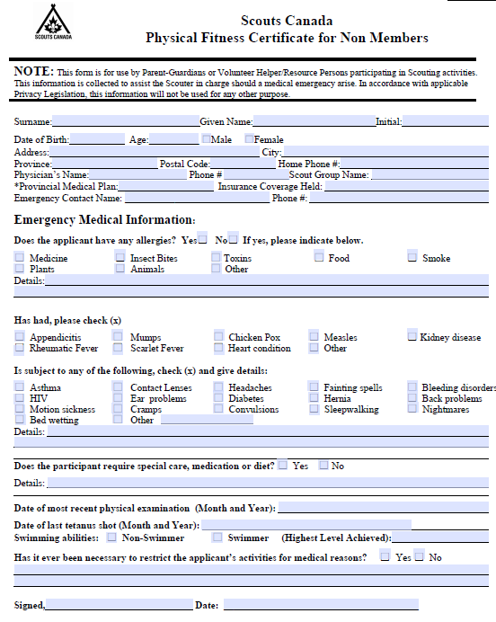
Odawa Area
Night Owl 2019
27 - 28 April 2019

REGISTRATION FORM
(To be handed in when registering Saturday afternoon/night 27 April 2019)

Scouting/Guiding Group Name: _____________________________________

Scouter/Guider in Charge: ______________________________

Scouter/Guider in Charge Cell Phone number: ___________________________________

Scouter/Guider in Charge e-mail address: _______________________________________

 | Qty | Cost | Total Cost
Number of Youth doing Hike |  | @ $15 each
Number Of Members volunteering to run stations/act as roving safety patrols (ie Rovers, Venturers, Rangers, senior Scouts/Pathfinders, Scouters/Guiders) |  | @ $7 each
Number of Adult Volunteers not necessarily running stations/doing roving patrol but on site with the Group anyway |  | @ $7 each
Total Group Cost

Paid by: Cash Cheque Cheque #:____
(Circle One)
Odawa Area
Night Owl 2019
27 - 28 April 2019
Team Registration Sheet
(To be handed in when registering Saturday afternoon/night 27 April 2019)

Group: _________________________________________
(Group name – ie: 8th Orleans/1st Maxville etc)

Group Contact Scouter/Guider: ___________________________ Cell No: ___________________________
(Name of adult Scouter/Guider attending camp and responsible for Group)

Team Name: _______________________________________________________________________

Team Youth Leader: __________________________ Youth Cell Nos: (1)___________________________
(Name of Youth Leader of the team)
(2) __________________________

Team Member Names (4- 7 members per team)

______________________________________________________

______________________________________________________

______________________________________________________

______________________________________________________

______________________________________________________

______________________________________________________

______________________________________________________

To be handed in as a paper copy upon registration Saturday afternoon/night along with copies of
Registration.

Physical Fitness forms (which can be found at http://www.scouts.ca/wp-content/uploads/forms/Physical-Fitness-Form_Non-Members.pdf ) for all participants (Youth and Adults alike) are to be sealed in a large ziploc bag with the Group Name and Contact Scouter/Guider – these forms will be returned to the Scouter/Guider in charge at the close of the activity Sunday morning.
Probable Stations for Night Owl 2019
(may be altered up to the day of the event)

This info should be shared with the Youth prior to the day of Night Owl
Ser | Station Name | Station Description | Manned by  (Scout/Guiding Group/Section)
1 | Mine Field | Given: Fake mine field (using card board or some other representation of mines)  Action: Patrols are divided in half , one half to be blind folded and guided verbally guided by the other half of the patrol with the members crossing the mine field doing so all together (simultaneously). If someone hits a mine, they all must go back to the beginning and start over.
2 | Spider Web | Given: A spider web (must be constructed in advance by the people running the station using a structure already onsite, using twine).  Action: Successfully traverse the spider web in accordance with instructions given on-site by the operators of the station.
3 | Map Grid Code | Given: Fake map grid containing letters  Action: Each patrol given basic instruction on how to locate something using map grid coordinates (in the how, up the stairs) and then they are given a set of five grid references from which they are to find the applicable letters to spell out a word  See https://www.nrcan.gc.ca/earth-sciences/geography/topographic-information/maps/9789 which has been extracted at the end of this document | Can be unmanned if necessary
4 | Tarp Toss | Given: A tarpaulin with different size slots cut into it and different size balls.  Action: Given max ten balls, Patrol members take turns trying to toss different size balls through holes in a tarpaulin.
5 | Knot Grid-Scouts/Guides are Knotty | Given: Bag of over sixteen (16) already prepared knots and a grid to hold sixteen (16) knots – this grid is made by aligning four 4X4 grid segments  Action: Patrol has to identify knots within five minutes by placing them correctly on a grid (note: there will be extra knots that do not go on the grid)
6 | Lock Box | Given: Two lock boxes with two different combination locks, one on each box.  Action: Upon arrival on site, using the lock box whose number has been assigned to them at Registration, follow the instructions on the box:  - on the outside will be a bearing and distance that they are to follow to find a tree with part of the combination to the lock along with a new bearing and distance to follow from the lock box to a new destination where the second part of the combo is to be found  - return to the box, unlock it and obtain a new bearing and distance that they are to follow to find another tree with a page of letters – immediately re-lock the box and, using the template that they were given at registration, place the template mask over the letters and determine secret word – write the word on the Patrol Score Sheet.
7 | Fire Making Challenge | Given: A mini fire pan with a string suspended  Action: Make a small fire and burn the string  Youth are to be encouraged to bring their own fire making kits to try them out if they have them and their Scouters/Guiders allow.
8 | Trivia Quiz | Given: Pack of trivia questions if unmanned or 15 Trivia Questions drawn from a grab bag.  Action: If unmanned, take a copy of the trivia quiz and sign in on the Station Register. Can be completed on site or along the hiking route. Must be handed in at the end of the hike at the Registration Desk.  If manned, 15 trivia questions are picked from a grab bag, 2 points for each correct answer. | Can be unmanned if necessary
9 | Rope maze | Given: Blind folds, twine, rope, guide lines, caribiners  Action: In silence, the entire Patrol is to be go one at a time with spacing of fifteen seconds between members, blind folding themselves at the start point and follow a guideline that is intersected with other guidelines with the goal of exiting on the right guideline – if one exits on the wrong guideline, they are eliminated. Physical contact with the guidelines (whether they are correct or not) is to be maintained at all time. They have seven minutes to complete the course with as many patrol members as possible.
10 | Kim’s Game | Given: Contents of an emergency kit or perhaps a jumble of other material, with an exposure of one minute  Action: Working together, Patrol members must identify items that were seen – three minutes given to make list.
11 | Lashing | Given: Three staves/poles, twine/rope, coffee can and clothes hanger  Action: Using rope/twine provided and, lash a three legged tripod from which a can of water can be hung over a fictitious fire
12 | Morse Code | Given: A Morse code aide memoire and a card containing a word/phrase coded using Morse code  Action: Working together, decode the sheet (and hand in results if unmanned at the end of the hike at the Registration Desk). | Can be unmanned if necessary
13 | Rope Crossing | Given: A heavy rope strong between two thick trees over a tarpaulin  Action: Team members one at a time must cross the tarpaulin using the rope without touching the tarpaulin.
14 | Semaphore | Given: A semaphore aide memoire and a secret word/phrase on a card spelled out using semaphore  Action: Team members must decipher the word/phrase | Can be unmanned if necessary
15 | Rope Bridge | Given: The rope bridge at the Beaver Pond near the NW field  Action: Two members of the Patrol must successfully cross the rope bridge while remainder of the Patrol cheers them on
16

Any other ideas from Youth/Scouters/Guiders for challenges for potential consideration for this year’s Night Owl are welcome – send to Scouter Stephen at Odawanightowl@odawa-scouting.ca – challenges must be such that teams can complete within five (5) minutes or multiple teams can undertake challenge at same time and not be equipment/material intensive. As well, challenges that need not have volunteers to run can be considered.

The UTM Grid - Military Grid Reference System
https://www.nrcan.gc.ca/earth-sciences/geography/topographic-information/maps/9789
Two systems are marked on National Topographic System (NTS) maps for identifying points with reference to the rectangular grid: Civilian UTM Grid Reference System and Military Grid Reference System described below.
Please read this note regarding an error in Military Grid references on NTS maps.
To begin with, if there is no possible confusion about the map sheet on which the reference falls, the Military Grid Reference System provides a very quick and easy method of referencing. The topographic maps carry a rectangular grid with numbers in the margin identifying the horizontal and vertical lines. On large-scale maps (1:50 000 and larger) each number consists of two digits as shown below:

The map reference
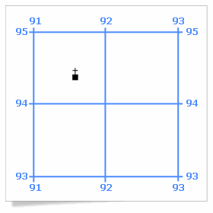
Figure 1 - The UTM grid
Figure 1 - Text version
Figure 1 is an illustration of a church superimposed over a UTM grid which makes it possible to obtain the map reference.
To arrive at a map reference for the church shown in Figure 1, we would first note the numbering of the lines that form the west and south of the square. For centuries, mathematicians have given the X coordinate before the Y coordinate; map users follow suit by quoting eastings before northings. Therefore the designation of the square containing the church would be 9194.
To give a reference for the church itself, we must imagine the square divided into 100 smaller squares (ten by ten). Then we estimate by eye that the church is six tenths of the way between lines 91 and 92, and four tenths of the way between lines 94 and 95. Using these figures, we can quote the easting as being 916 and the northing as 944. By convention these are combined into a reference of 916944.

