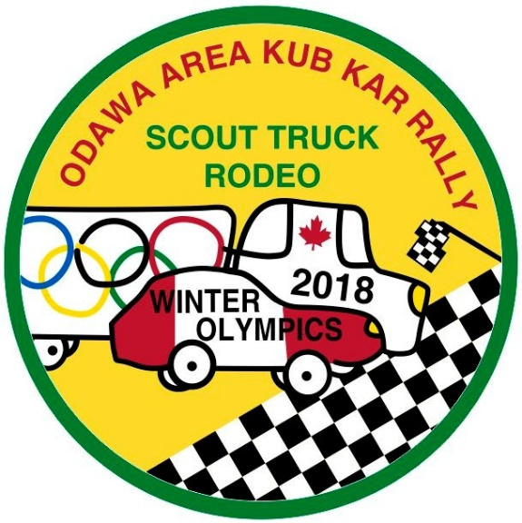
Registration Form and
Information Package
When: Mar. 3, 2018, 9:30 a.m. to 2:30 p.m.
Where: Jean-Marc Lalonde Arena, Rockland
Registration deadline: Sunday, Feb 25, 2017

Scouters: Please use one form for Pack and another one for Troop.

Group and Section:
Contact Scouter:
Phone/  mobile nos.: |  |  |  |  | Email:
Cubs and Scouts ($15) | No. of Youth |  | Total due for youth |  | Scouters and parents  ($7) |  |  | No. of Scouters/parents |  | Total due for Scouters/parents
 |  |  | $ |  |  |  |  |  |  | $
Total participants: |  |  |  |  | Total due: $
Participant Name |  |  |  | Scouter (S) or Parent (P) |  | Youth: Kub Kar Rally | Youth: Scout Truck Rodeo |  | Dietary Restrictions or other notes
Mowgli O’Jungle |  |  |  |  |  | X |  |  | Water to Drink
Participant Name |  |  |  | Scouter (S) or Parent (P) |  | Youth: Kub Kar Rally | Youth: Scout Truck Rodeo |  | Dietary Restrictions or other notes

When and where
- March 3, 2018
- Jean Marc Lalonde Arena, Rockland, Ontario (1450 Du Parc Avenue)
- Doors open: 9:00 a.m.
- Opening ceremony: 10:00 a.m.
- Pick-up: 2:30 p.m.
Registration
- Registration deadline: SUNDAY, FEBRUARY 25
- Complete the registration forms for your Pack and your Troop email them to 1stCumberland@gmail.com.

Payment
- Cost: $15 per Cub/Scout and $7 per Scouter/parent (includes lunch and crest)
- Note: You must pay for the people registered even if they can’t attend (the food will be purchased and prepared according to registration numbers).
- Bring payment for your Pack and Troop with you to the event. Make cheques payable to “Scouts Canada — Odawa Area”.

Lunch
- Large all-beef hotdog or vegetarian option
- Bag of chips
- Juice or water
- Please note any dietary requirements on the registration form

Volunteers needed for
- Registration
- Vehicle check-in
- Pit crew
- Scoring
- Monitoring start at tracks
- Scoring at bottom of tracks

To help the day go smoothly
- Bring:
  - Indoor shoes
  - A sweater or fleece (it’s an arena)
  - Water bottle
  - Nut-free snacks
  - Books, deck of cards, crafts, etc., to use during a lull in programming (final races, Scouter races)
- No running or climbing in the arena or stands (all Scouters, please enforce)

Schedule
9:30 a.m. | Arrival and registration  - There will be designated areas in the stands for each section and group to stash their gear for the day. Please ensure that your families know which section and group to look for to lessen confusion upon arrival. Kub Kars and Scout Trucks are racing in the same arena, so we are sharing the space.  - Parents are welcome to remain in the stands for the duration of the event, but should not go onto the arena floor.  - Once all your Cubs/Scouts have arrived, one Scouter from each Pack and one from each Troop must go to the registration table to pick up the registration package and deliver payment. Do not send parents to the registration table.  - Once you have your Pack’s or your Troop’s registration package, make your way (with the Cubs or Scouts) over to the weigh-in station. Once their vehicle is weighed-in, Cubs and Scouts can continue to the Pit Crew if any modifications are required.
10:00 a.m. | Opening  - Go to the arena floor with your group for opening; be prepared to be loud and proud!
10:15 a.m. | Racing begins
12:00 noon | Lunch (included)  - During the lunch break, return to your place in the stands and wait for your Pack or Troop to be called. Then send one Scouter per Pack or Troop to the canteen window to pick up the lunches.  - Please put all your trash in the garbage bins by the end of the lunch hour. Cubs and Scouts may continue to race once they are finished lunch.
1:00 p.m. | Scouter races and finals  - Cubs and Scouts can watch Scouter races and finals or amuse themselves. Be prepared!
2:00 p.m. | Awards and closing
2:30 p.m. | Event ends, Cubs and Scouts to be picked up

